BREAKOUT OPTIONS
PLEASE DRAW OUR BREAKOUTS---------
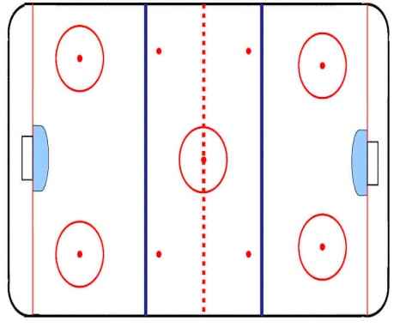
D TO D D1 moves the puck to his partner
on the weakside of the ice. D2 then
makes first pass to Fwds in their
support positions.

WHEEL
D1 carries and uses net to take
the middle lane. D2 hinges back as
an option. Fwds support low in their
lanes as options.

QUICK UP
D1 gets to puck quickly and turns to
face up ice. D1 identifies option in the
middle or strong side wall. Weak side
forward comes across for support.

REVERSE
D1 acts as if he is wheeling. He sucks
forechecker to him as he drops the puck
behind. D2 hinges behind and picks up
puck to turn up ice. D2 now headman’s.
- All breakouts depend on where pressure is coming from. Players must read the pressure and recognize the proper breakout option. Communication and awareness is important. These options can be used all over the ice.
LOW SEAM
D1 quickly recognizes a low seam and moves
the puck to F3. Done when opposition sends
three on the forecheck. This is a quick up
option. Must be 100% sure the seam is open.

CONTROLLED(breaking out vs 1-2-2 passive)
D1 stops behind the net. F1 supports in one
corner as D2 moves to the other corner. D1
steps out on forehand and sucks forechecker
to him. D1 then drops puck to F1/D2 who have
timed the play. F1/D2 take middle lane and move
up ice with other players that have supported
low in their lanes.
WEAK SIDE RIM STRETCH
D1 picks up puck on strong side and rims puck Another quick up option where D1
around boards to F3 who anticipates and moves gets to puck early and recognizes a seam
low to half wall. Supporting Fwds come across low D1 moves puck up ice to player moving
in the zone to receive head man pass. with speed.

