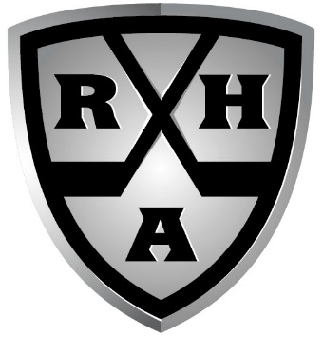
COACHES EXPECTATIONS
Each player that plays for the Riggers Hockey Academy must agree to follow all of the listed team rules and expectations throughout the course of the event.
As a member of the Riggers you are expected to:
- Follow team Dress Code… We will have a dress code for all games and team meals while in Nashville this will be Golf Shorts/Pants, Nice Runners/Dress Shoes, Golf Shirt or Dress Shirt (no tie) this is with the exception of breakfast in the hotel.
- No Swimming while we are still competing
- 10pm curfew; lights out and in bed
- ABSOLUTELY ZERO TOLERANCE ON BULLYING!
- Be fully committed to the team. We must be a cohesive unit in order for us to achieve our goal.
- Be respectful at all times. Including when you are away from the rink. You are representing your TEAM, FAMILY, COMMUNITY and YOURSELF. While at the rink we will behave like professionals. Watch others play and as we focus on our games.
- Listen to your coaches and accept their feedback
- Support the team’s goals. Be a leader!
- Be prepared to be engaged and give 100% every time you step into the rink.

