5 RULES FOR OFFENSIVE HOCKEY
We play offensive hockey when we have 100% control of the puck, not before.
- All players need to learn all positions because of the need for rotation. i.e.: F1,F2,F3, etc..
- All six players on the ice are involved in the offence.
- All offensive plays should involve width and depth.
- All offensive play should be designed to create a 2 v 1 situation, which then must be executed to create a clear shot on net, from a good shooting area
- Puck control is the main objective to be achieved through good passing and receiving, moving into openings and not giving the puck away. Attacking with speed is very important
We must gain possession of the puck and quickly transition onto offence. Awareness to find seams and openings is key. We then will attack with speed while we support the puck, in order to move it into the scoring zone. Once the puck enters the scoring zone we need to ‘shoot to score’ and attack the net for tips/screens/rebounds. PLEASE DRAW THE ‘SCORING AREA BELOW’
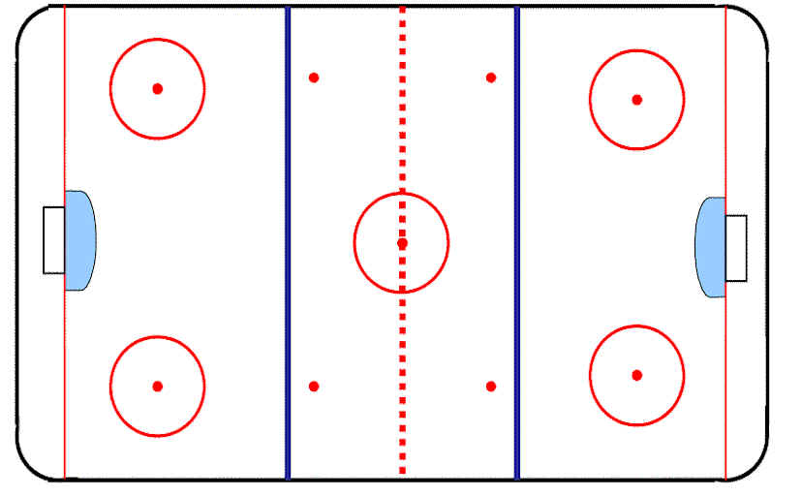

YOUR CHARACTER IS DEFINED BY YOUR ACTIONS.
YOUR ACTIONS REPRESENT WHO YOU ARE, YOUR WORDS ARE WHO YOU WOULD LIKE TO BE!

